Kellogg School of Management Northwestern University
 Kellogg

SEEK 460: Values Based Leadership

Section 71

Fall 2008

Professor David Austen-Smith
Leverone Hall Room 530

Phone: 847-467-3496
E-mail: dasm@kellogg.northwestern.edu

TA: Eileen Chou: e-chou@kellogg.northwestern.edu

CONTENTS
Course Overview Page 2
Course Requirements Page 3
Class Schedule and Topics Page 5
Group Evaluation Form Page 15

Course Overview and Objectives

This course focuses on the ways in which leaders must recognize and respond to a variety of competing value propositions both within and outside their organizations. Whereas practical leadership typically involves the creation of incentive systems, values-based leadership also motivates through the creation of norms, by example and inspiration. In today’s world leaders are expected to not only appreciate competing value propositions but also be able to articulate and advocate principles and standards of behaviour. To achieve these goals requires the ability to anticipate not only how others will respond to the interaction between incentives and values-based approaches but also how emotions drive attitudes and behaviour.

Values-based leadership ultimately involves the ability to take the disparate value propositions of various stakeholders and integrate them into a coherent vision. Doing so requires the capacity to make tough choices, to take a stand and to offer an articulate and coherent justification for one's decisions. The course helps to develop this ability to consider a wide-range of value perspectives and to integrate them when making hard decisions.

During the course, we explore how recognizing and incorporating competing values claims throughout the organization is often facilitated and hindered by a number of psychological, organizational and cultural processes. Students will come to understand the variety of underlying mechanisms managers of organizations typically have at their disposal to implement values objectives successfully and to select among the different approaches, while anticipating the constraints placed on choice by the organization's market and non-market environments.

Although some of the material we will cover in the class may be found in a standard business ethics course, it is important to emphasize that, in contrast to such courses, our goal is not the ethical or moral transformation of students. Instead, our goal is to develop a set of tools and frameworks where possible that allow students to manage effectively in a world increasingly characterized by stakeholders with competing values.

Course Format:
Each session focuses on various perspectives and challenges that are confronted in the ethical realm of organizational life. We develop tools with which to discern the relevant value propositions in any given situation by discussing key theoretical concepts and analyzing related cases. You should come to class prepared to summarize key points from the day’s readings and to contribute to the case analysis. As you complete the readings, ask yourself:
- What is the basic argument the author makes?
- What are the key concepts and principles?
- So what? How does this matter for an organization?
- What are the implications for the kinds of challenges I may face as a leader?
- How can I apply this to my firm, my job, and my career?

The course reflects a dual focus on practice and conceptual training. The articles in the course packet introduce key concepts and useful ways of thinking about complex situations in organizations. Case studies and class exercises provide opportunities to apply theories, concepts, and research findings to particular situations and to hone your skills in defining ethical dilemmas and constructing appropriate solutions. The written assignments ask you to consolidate your insights and to apply your own conception of values based leadership.

Course Requirements and Assignments

Assignments:
Your final grade is composed of:
- Course Contribution 10%
- Individual Reflection Papers 25%
- Group Projects 25%
- Final Exam 40%

Course Contribution (10%)
All class sessions involve active discussion based on the readings and cases, with an emphasis both on theoretical questions and practical implications. You should be prepared to share your ideas and listen to and interpret the issues presented by others.

Please review the readings and case for every class session carefully. Most participation will be voluntary; however, to ensure that everyone has the opportunity to be involved, individuals will occasionally be called upon “cold.”

Quality discussion comments possess one or more of the following attributes:
- Offer a relevant perspective on the issue
- Provide careful analysis
- Apply the theory and concepts offered in the readings and lectures
- Move the discussion forward by building on previous contributions with new insights; do not repeat points already made by others
- May include asking good questions. This is a skill to be practiced as well; good questions are rarer than good answers.

Regular participation in discussions and class exercises is expected. If you must miss a class, it is essential that you notify me at least 24 hours in advance so that I can make arrangements for any in-class exercises and so that you can be certain to get the materials that will be distributed during the class.

Reflection Papers (25%)
You will be asked to write three reflection papers. The purpose of the reflection papers is to encourage you to reflect on your past behaviour and experiences in which value and ethical considerations were brought to bear so that you will have greater perspective in the future. There are three individual reflection papers due weeks 2, 4 & 8 at the beginning of the class.

Group Projects (25%)
You will be assigned to a Study Group for this course. You will work with this Study Group on two group projects, due in weeks 3 & 10. The first group project is the Food Aid case. Your study group will be assigned one of four perspectives for that case. The second group project requires your group to develop a presentation for the Genzyme case. Further information will be provided on the first day of class.

Group Evaluations: You will have the opportunity to evaluate the preparation and work completed by your Study Group teammates. See the evaluation form in this syllabus for the specific criteria on which you will evaluate each other. These evaluations will be factored into the course contribution grade.

Final Exam (40%)
The exam is a take home exam, due via e-mail at 5pm, Monday December 8th (date to be confirmed). It will test your knowledge and understanding of all the relevant concepts explored in the class.

Office Hours:
I will be available to meet with you in my Wieboldt Hall office between 5pm-5:45pm on Wednesdays. If you would like to make an appointment to see me at another time, please contact me.

Consideration for Classmates:
A class requires careful attention to fairness and mutual respect for one another. You are expected to attend every class on time and to stay for the entire class session. If you have an unavoidable conflict, please do not disturb your classmates by arriving late, leaving early, or asking to have information you missed repeated during the class. Always let me know at least 24 hours in advance if you will miss a class session so that I can make arrangements for any in-class exercises to be certain that your classmates do not suffer from your absence. This advance notice will also allow us to make arrangements to ensure that you get all of the materials distributed in that class.

If you are familiar with a case or an exercise introduced in class, please do not discuss your prior knowledge with other students, as this can ruin the learning experience for them. Telling other students (in any section) about your experience with cases and exercises is an honour code violation. If you are concerned that your prior experience with a case might be an issue, please let me know before class.

This course adheres to the guidelines established in the Kellogg Honour Code and the Kellogg Code of Classroom Etiquette.

Value Propositions
Week 1

Objectives:
Leaders of all organizations must confront and resolve conflicts of values, not only their own conflicts but also values conflicts within and between other stakeholders. The first week of the class will focus on the class setup including getting organized for the first group project (due next week). This class will consider the way in which values motivate action and the ways in which values change in predictable ways. There is also an in-class group exercise in which each group will be asked to make a decision about selling a potentially defective product in the developing world.

Read:
- Friedman: The Social Responsibility of Business
- Arrow: Social Responsibility and Economic Efficiency
- Friedman/Mackey debate

Case:
- To be handed out in class.

Discussion Questions:
- What social goals can market competition promote?
- Do you agree with Friedman that corporate managers have a moral imperative to maximize stockholder value?
- What are the principle economic reasons that might undermine Friedman’s position? Do you find these reasons compelling?

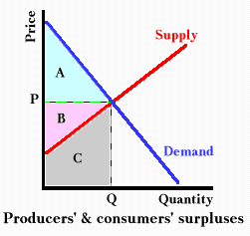

Fairness and Rights
Week 2

(Please bring a laptop computer to this class)
Objectives:
Some of the most difficult values conflicts concern allocating scarce resources. While it seems such choices are difficult many people believe that, at the end of the day, people agree on how such conflicts should be resolved. The class includes an exercise relating to the allocation of kidneys and we shall also discuss the results of the “Tough Choices” survey.

Read:
- Feinberg: Distributive Justice

Case:
- Handed out in class

Discussion Questions:
- Do individuals have an obligation to reduce poverty? Do corporations?
- How do group identities affect conceptions of distributive justice?

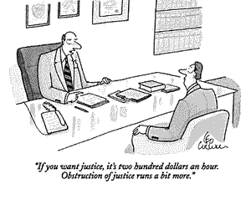

DUE: (1) First Individual Reflection Paper. In a page or less, answer the question: “Should people be permitted to sell their organs?” Identify the key value propositions in your argument. (2) Brief on-line survey: “Tough Choices”

Principles, Principals and Agents
Week 3

Objectives:
Consider in greater depth the nature of values conflicts, standard values propositions (e.g., fairness, welfare and consequentialist and deontological) and ask first, how people actually resolve values conflicts and then confront the question of how we ought to resolve such conflicts. We build upon the case we did in class the previous week and integrate classical perspectives on ethics and duty. In addition we link perspectives from economic theory on principals and agents with empirical findings on how people resolve value conflicts from the psychology literature.

Read:
- Machiavelli: The Prince
- Plato: The Republic
- Abraham Lincoln’s Letter to Horace Greeley
- Martin Luther King Jr.: Letter from Birmingham City Jail
- Kidder: The Ethics of Right versus Right, Justice versus Mercy
- Singer: Rich and Poor

Case:
- Food Aid

Discussion Questions:
- What do Lincoln, Machiavelli, King and Plato suggest are the primary obligations of a leader? Which conception, in your opinion, most accurately describes business leaders?

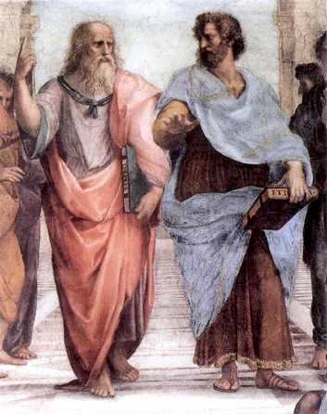

DUE: First Group Project: Food Aid

Stereotyping and Discrimination
Week 4

(Please bring a laptop computer to this class)
Objectives:
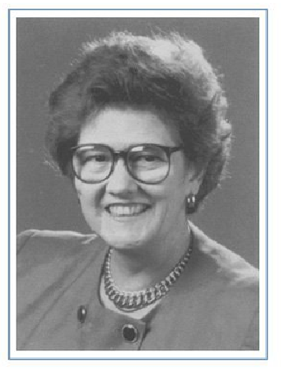
One of the most difficult problems facing managers centres on building a diverse workforce. Stereotyping leads to bias and discrimination in ways that counterproductive both at the firm and societal level. Nevertheless, management and government interventions often result in highly charged and difficult discussions. This session focuses on a discussion of the Anne Hopkins case and looks at the way in which stereotyping and bias operate at a nearly subconscious level. The class will also focus on the rationales for addressing discrimination and look at solutions managers can use to build diversity

Read:
- Banaji, Bazerman, & Chugh: How (Un)ethical Are You?

Case:
- Anne Hopkins

Discussion Questions:
  - What do you think contributed to the way Anne Hopkins was treated? What could Price Waterhouse have done differently?
  - What approach could organizations use to manage diversity?

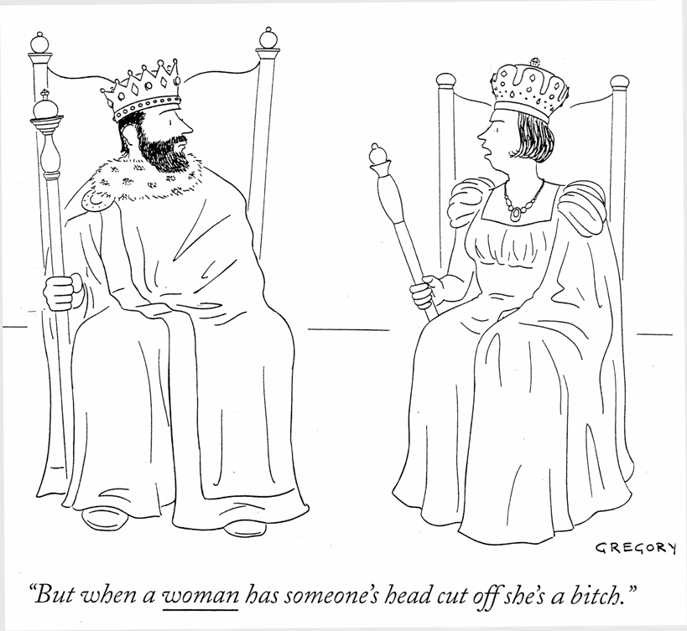

DUE: Second Individual Reflection Paper. Suppose you are faced with discrimination in the workplace. In a page or less, address how you should respond: when (if ever) should you play with the rules (e.g. take your wedding ring off during an interview) and when (if ever) should you fight to change the rules?
Emotions and Perspective Taking
Week 5

Objectives:
This week we look at the connection between values propositions and emotions. Emotions are the drivers of human behaviour. It is easy to come up with examples in which people act out of emotions that conflict with their core values. On the other hand emotions can be a primary driver of values based behaviour. The class uses the McLibel case to explore the ways in which emotions seemed to drive key decision-makers, and we discuss recent research in psychology and behavioural economics that sheds light on the way emotions impact strategic decision-making.


Read:
- Bazerman, Loewenstein, & Moore: Why Good Accountants Do Bad Audits
- Greene, Sommerville, Nystrom, Darley, & Cohen: An fMRI Investigation of Emotional Engagement in Moral Judgment
- Lerner: Negotiating Under the Influence; Effect of Anger on Detecting Interests

Case:
- McLibel Case

Discussion Questions:
- What, if any, difference is there between decision making based on emotions and decision making based on value propositions?
- When and what type of emotions lead to moral behaviour and maximizing self-interest, and when do they blind people from their own best interests and the interests of others?


What's to Be Done? Managing Values through Incentives and
Informal Mechanisms
Week 6

Objectives:
Leaders have a range of potential interventions available to motivate organizations. Economists naturally focus on material incentives (rewards and punishments) to motivate action. To this point, the class has focused on the way in which people are motivated by concerns that go beyond simple self-interest. This class looks at implications of ethically motivated behaviour for management interventions. Beginning with exploring the ways in which introducing material incentives into situations in which behaviour is driven by values concerns can sometimes be counterproductive, the class goes on to explore alternative interventions that leverage values to persuade rather than compel.

Read:
- Buchanan: Charity begins at Homo sapiens

Case:
- To be handed out in class.



Speaking Truth to Power
Week 7

Objective:
More often than they would like managers have to confront situations in which customers, employees, suppliers, or o even their bosses engage in unethical or illegal behaviour. In the worst case, the manager is confronted with a choice of confronting the unethical behaviour and risking a valued client, a job or worse, versus not confronting the behaviour and becoming morally or legally liable. The goal of these sessions is to develop skills and approaches for dealing with ethical violations by subordinates, peers and those in positions of power.

Read:
- Glazer: Ten Whistleblowers and How they Fared
- Johnson: Whistleblowing: When it Works and Why, ch. 1

Case:
- To be handed out in class

Discussion Questions:
- Define whistleblower as the public revelation of information about an organization or another individual’s behaviour that leads to the potential sanction of that organization or individual by others. What parameters of the situation determine whether you have an obligation to “blow the whistle”?
- Whistleblowing often leads to retaliation for the whistleblower. Come up with some alternative strategies that you could advise a whistleblower to pursue that don’t require whistleblowing.



Values-Based Marketing
Week 8

Objectives:
Values-based marketing focuses on the practice and ethical implications of marketing values. Marketing itself has its origins in modern psychology and was originally known as propaganda. Obviously, propaganda has acquired quite negative associations as a result of the way totalitarian regimes leveraged propaganda for purposes of social control. The class considers the connection between propaganda and marketing on values. We also discuss the Unilever Dove and Axe campaign and Toyota’s recent success with the Prius hybrid.

Read:
- Pratkanis and Aronson: Age of Propaganda pp.48-67
- NY Times: Say ‘Hybrid’ and Many People Will Hear ‘Prius’
- Daily Mail: Are we falling for the great green con?
- Businessweek (June 2007): Failure of Accord Hybrid is Marketing Fiasco
- OpEd by James Martin: Hidden costs of driving a Prius

Case:
- Unilever: Dove and Axe

Discussion Questions:
- What are the values that underlie the Dove and Axe campaigns? Are they in conflict?
- Sales of the Toyota Prius are rising while sales of other hybrids are declining. Market research suggests that the Prius is benefiting because consumers are using it to make statement about themselves. Does this matter?



DUE: Third Individual Reflection Paper. Recent research on lifecycle costs of the Toyota Prius (see OpEd by James Martin) suggests that the Hummer may have a smaller energy impact than the Prius when considered over the lifecycle of ownership. What, if any, effect do you think this research is likely to have on Prius and Hummer sales?

Building Culture: Values Statements
Class 9

Objectives:
This week’s class looks at the ways in which entrepreneurs and managers build values into their organizations and how this can create difficult values conflicts. The class will discuss the Veridian case and the Kellogg Honor Code.

Read:
- Kidder: Core Values
- Kinni: Words to Work By: Crafting Meaningful Corporate Ethics Statements

Cases:
- Veridian and Kellogg Honor Code

Discussion Questions:
- Given the processes inherent to conflicts of interests (and that warnings seem to be ineffective), what remedies would you propose to deal with this vexing problem? Think of one way to eliminate the self-serving biases that spring from many incentive plans.
- After a company creates a value statement, how might the company encourage employees to adopt its ideals?
- How well does the Kellogg Honor Code work? What, if anything, should students, faculty and the administration consider changing about the honor code and its administration to make it more effective?

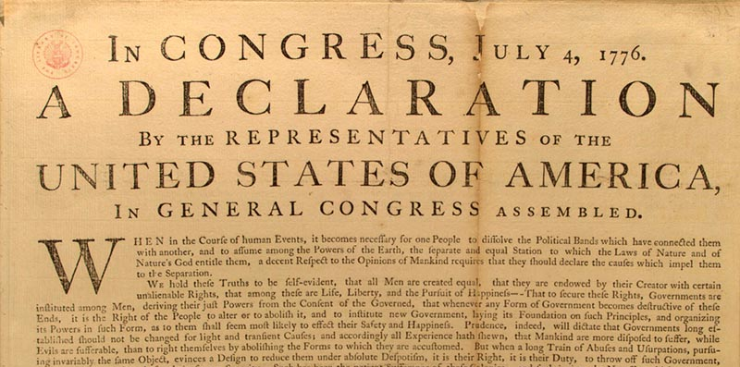

Global Environment and Corporate Social Responsibility

Class 10

Objectives:
The concluding class explores the way that globalization has created unprecedented social problems and values conflicts that are likely to be the defining features of our professional lives.

Read:
- Donaldson: Values in Tension: Ethics Away from Home
- Vogel: Is there a Business Case for Virtue?

Cases:
- Unocal Pipeline and Genzyme

Discussion Questions:
- Suppose that the CEO of Unocal decides to do the gas pipeline project with the Burmese government. Who are the critical stakeholder groups and what should the CEO tell them?
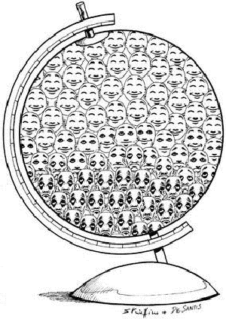

DUE: Second Group Project. Your group will develop a presentation on the Genzyme case.

Group Evaluation
Please use this form to evaluate all of the members of your group, including yourself, on your work together analyzing the cases and preparing presentations and memos. Grade each group member using the comparative scale below. Awarding a teammate a “1” would indicate that his or her initiative, dependability, etc. went above and beyond that of the other team members. In contrast, a “-1” would reflect efforts that they weren’t up to par with the other teammates’ inputs – that the person could have done more to carry a fair portion of the workload. A zero would indicate that the team member’s efforts and contributions were equal to that of most of the other group members.

[-1]……[-0.5]……[0]…...[0.5]...…[1]
Could have done more equal exceptional contributions

Team Member Name | Quality of Contribution | Dependability | Initiative

Additional comments (if necessary)

